A
PROJECT REPORT
ON
“Online Attendence System”

Submitted for the partial fulfillment of the Degree of Bachelor of Engineering in Computer awarded by Pokhara University



SUBMITTED BY
Nikit Pandey [21070562]
Ranjan Paudel [21070565]
Suman Sharma [21070579]
Shiva Kumar Bhandari [21070575]
SUPERVISOR
Shiva Kumar Bhandari

SUBMITTED TO:

DEPARTMENT OF COMPUTER ENGINEERING
POKHARA ENGINEERING COLLEGE
PHIRKE, POKHARA-8
2025

CERTIFICATE
Date: 2024/07/01

This is to certify that the project entitled “Online Attendance System” has been carried out by Nikit Pandey (21070562), Ranjan Paudel (21070565), Suman Sharma (21070579) and Shiva Kumar Bhandari (21070575) in partial fulfillment of the degree of Bachelor of Engineering in Computer of Pokhara University, during the academic year 2023. To the best of our knowledge and belief, this work has not been submitted elsewhere for the award of any other degree and thus has been accepted.

----------------------------
Er. Safal Thapa Project Supervisor

----------------------------
Er. Suraj Basant Tulachan HOD, Computer & Electronics

----------------------------
Er. Krishna Ghimire Research & Development Chief

ACKNOWLEDGEMENT

We would like to express our special thanks of gratitude to our teacher Er. Safal Thapa for his valuable guidance, encouragement and support to complete this project.
We are also thankful to our HOD Er. Suraj Basant Tulachan, , and whole college department for this golden opportunity.
Finally, we would like to thank to our friends and families for their support to help us finalize this project within the given time period.

Nikit Pandey [21070562]
Ranjan Paudel [21070565]
Suman Sharma [21070575]
Shiva Kumar Bhandari [21070579]

ABSTRACT

This report details the creation of an online attendance system to simplify and improve attendance tracking in schools. The system allows students to log in, mark attendance, and receive email notifications, while teachers and administrators can manage records through an admin panel. The system addresses issues with manual attendance like time consumption, errors, and data management difficulties. It provides quick, accurate, and real-time attendance records. The development process included requirement analysis, system design, development, testing, and deployment. The report also compares other methods, highlighting the benefits of this online system.

ABBREVIATIONS

- ER: Entity-Relationship
- PK: Primary Key
- FK: Foreign Key
- HTML: Hyper Text Markup Language
- CSS: Cascading Style Sheets
- JS: JavaScript
- SQL: Structured Query Language
- UI: User Interface

LIST OF FIGURES
5.1.ERDiagram……………………………….……………………………………..…………….20
5.2.SequenceDiagram……………………………………………….…………………………….22
5.3.UseCaseDiagram……………...………..………………………………..……………………….23
Appendix…………………………………………………………………………….….………….29

LIST OF TABLES
4.4.1. Database Table for Attendance………………………………………………………24
4.4.2. Database Table for class………………………………………………………………24
4.4.3. Database Table for Course………………………………………………….…….……24
4.4.4. Database Table for Teacher…………………………………………..………….……25
4.4.5. Database Table for Student…………………………………………………………..25
5.1. Test Cases and Result………………………………………………...………………..27

TABLE OF CONTENTS

CERTIFICATE 2
ACKNOWLEDGEMENT 3
ABSTRACT 4
ABBREVIATIONS 5
TABLE OF CONTENTS 8
CHAPTER 1: INTRODUCTION 9
1.1. Background 9
1.2. Statement of Problem 10
1.3. Objective 11
1.4. Scope of Project 11
1.5. Limitation 12
CHAPTER 2: Literature Review 13
2.1 Preliminary Study 13
2.2 Similar Tasks 13
CHAPTER 3: METHODOLOGY 14
CHAPTER 4: Project Schedule 15
CHAPTER 6: TESTING 23
6.1. Test Cases and Result 23
CHAPTER 7: CONCLUSION 24
CHAPTER 7: REFERENCE…………………………………..………………………………29
APPENDIX…………………………………………………………………………………...30

CHAPTER 1: INTRODUCTION

An online attendance system is a digital solution designed to manage and track the attendance of students in educational institutions. This report provides an overview of the system, including background information, the statement of the problem, objectives, scope, limitations, a literature review, and the methodology used for the development and implementation of the system.

Background
- Social Aspects
In today's educational system, there is a growing importance on the integration of technology to enhance learning experiences and simplify administrative tasks. The increasing use of digital platforms in education has made it essential for institutions to adopt efficient systems for managing student information, including attendance. An online attendance system supports this trend by offering a modern, user-friendly interface that aligns with students' and teachers' familiarity with digital tools. It also fosters a culture of accountability and punctuality among students, as they are regularly reminded of their attendance status through automated notifications.
- Economic Aspects
Implementing an online attendance system can lead to significant cost savings for educational institutions. Traditional methods of attendance tracking often involve paper-based systems, which incur costs related to printing, storage, and administrative labor. By transitioning to an online system, institutions can reduce these expenses and allocate resources more effectively. Additionally, the automation of attendance management minimizes the need for manual data entry and reduces the risk of errors, thereby improving overall operational efficiency. The initial investment in developing and deploying the system is offset by the long-term savings and increased productivity it provides.

- Geographical Aspects
Geographically, the online attendance system is particularly beneficial for institutions with multiple campuses or those located in remote areas. It allows for centralized management of attendance data, enabling administrators to monitor and analyze attendance patterns across different locations in real-time. For students in rural or remote areas with limited access to physical campuses, the system provides a convenient way to participate in classes and have their attendance recorded accurately. Furthermore, the system can be accessed from any location with an internet connection, making it versatile and adaptable to various geographical settings.

Statement of Problem

Manual attendance systems in educational institutions present several significant challenges:

Time-consuming and prone to errors, with difficulties in maintaining and organizing records.

Susceptibility to inaccuracies and manipulation, challenging the authenticity of recorded attendance.

Significant administrative effort required for compiling and analyzing attendance data, leading to delays in reporting.

Inability to monitor attendance in real-time, resulting in delays in identifying and addressing absenteeism patterns.

Manual systems struggle to scale with larger institutions, increasing complexity in managing attendance across multiple classes and departments

Objective

To create an easy-to-use attendance system for students, teachers, and admins.

To provide real-time data and facilitate easy data management.

To provide reminders to encourage improved attendance and engagement.

Scope of Project
- Development of a web-based application: The application will be accessible from various devices including computers, tablets, and smartphones.
- Student login functionality: Secure authentication for students to mark their attendance.
- Attendance marking: Options for both manual and automated attendance marking.
- Email notifications: Automated emails to notify students and administrators about attendance records.
- Admin panel: For teachers and administrators to manage student records and generate attendance reports.

Limitation
- The system needs a reliable internet connection to function properly.
- Areas with poor connectivity may experience limitations.
- Initial Setup Cost: There are upfront costs associated with developing and launching the system, which might pose financial challenges for some institutions.
- User Training: Users, including students and staff, may require training to fully grasp and utilize the system effectively.

CHAPTER 2: Literature Review

Preliminary Study

The preliminary investigation of the project looked at whether it would be possible to develop an online attendance system for educational institutions. This involved examining existing attendance tracking methods, identifying challenges faced by teachers. Additionally, the study considered factors such as user requirements, data security, and system scalability. The insights gained from the study will help make informed decisions and plan the project effectively.

2.2 Similar Tasks
Several relevant projects and existing online attendance systems were reviewed during the literature review phase. These serve as valuable references for understanding the scope and possibilities within this domain. Notable tasks examined include:
• AttendEasy: An online attendance system designed for educational institutions, offering features such as real-time tracking and customizable reporting.
• ClassTrack: An attendance management system that integrates with available school systems, providing features like attendance recording and analysis.
• AttendancePro: A cloud-based attendance tracking solution tailored for schools and universities, offering features such as biometric authentication and predictive analytics.
The literature review phase has provided valuable understanding of the existing research and projects in this field of online attendance systems. This knowledge serves as a foundation for developing this project, ensuring that it meets the needs of educational institutions and enhances attendance management processes.

CHAPTER 3: METHODOLOGY
The Agile methodology is well-suited for this project due to its iterative and flexible nature. This approach allows for continuous feedback, quick adjustments, and constant improvement, which are essential for developing an effective online attendance system.
- Requirement Gathering and Analysis : Meetings with stakeholders to understand needs and gather requirements.
- Planning : Breaking down the project into tasks and creating a timeline. Design Creating wireframes, mockups, and system architecture.
- Development : Developing the system in iterative sprints, implementing small sections at a time.
- Testing : Performing various tests to ensure functionality and meet requirements.
- Deployment : Deploying the system for real-world use and providing user training.
- Maintenance and Feedback : Collecting user feedback, monitoring performance, and making updates.

Flowchart:
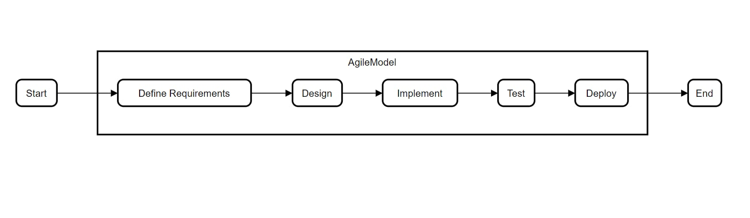

CHAPTER 4: Project Schedule
Estimated Timeline: 30Days
Phase 1: Project Planning and Preparation (4 days)
• Define project requirements and objectives
• Conduct research and gather relevant resources
• Create a detailed project plan and timeline
• Set up development environment and tools
• Finalize project plan and prepare for implementation
Phase 2: Design and Prototyping (4 days)
• Design wireframes for user interface
• Develop mockups based on wireframes
• Review and refine design with stakeholders
• Create clickable prototypes for key user flows
• Conduct usability testing on prototypes
Phase 3: Development Phase 1 (8 days)
• UI development (HTML/CSS)
• Build Interactive elements.
• Ensure navigation and accessibility for users to record and view data.
• Conduct testing and debugging of implemented features
• Address any issues and refine codebase.

Phase 4: Development Phase 2 (8 days)
• Handle user authentication, process attendance data on server side.
• Validate user inputs, process attendance data and execute business logic.
• Create database and integrate in order to store and manage records.
• Conduct testing and debugging of new features
• Address any issues and prepare for final deployment.
Phase 5: Finalization and Deployment (6 days)
• Finalize remaining features and conduct comprehensive testing
• Prepare for deployment, including setting up hosting environment.
• Deploy the platform to a staging environment for final testing
• Address any issues and prepare for final deployment.
Phases | May  10-15 | May  16- 20 | May  21- 30 | June  1-8 | June  9-15
Project planning and preparation
Design and Prototyping
Development Phase I
Development phase II
Testing and Debugging
Finalization and Deployment

CHAPTER 5: SYSTEM MODELING
5.1. ER-Diagram

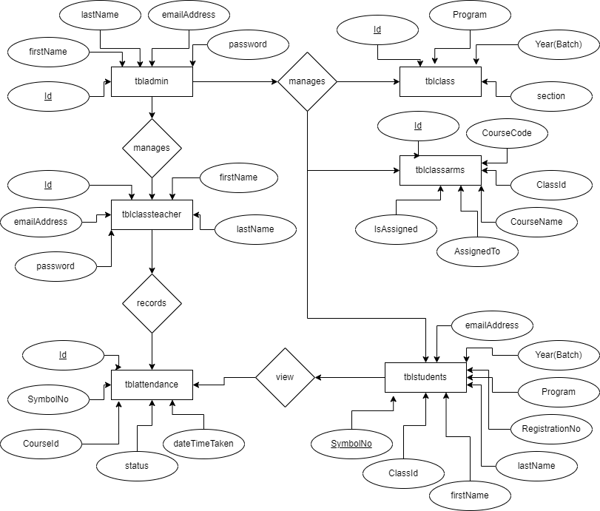

Fig: ER-Diagram

5.2. Sequence Diagram

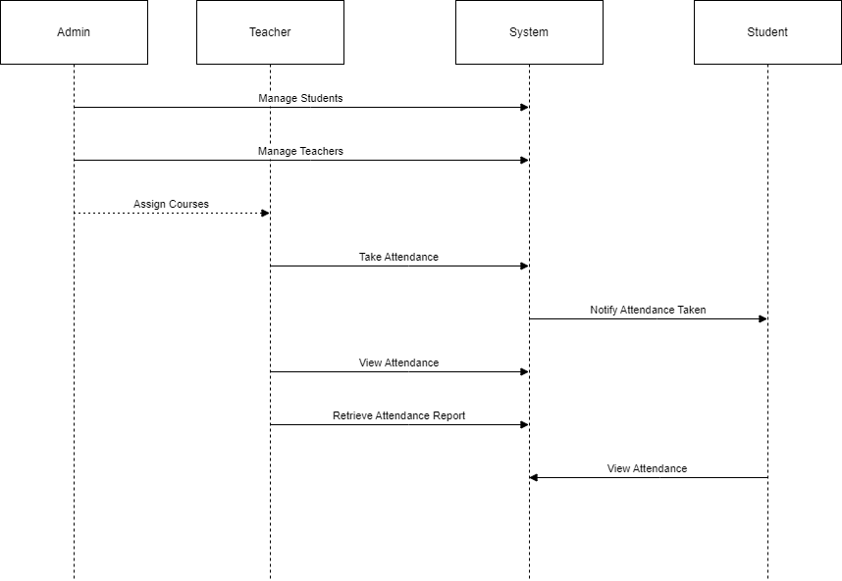

Fig: Sequence Diagram

5.3. Use Case Diagram

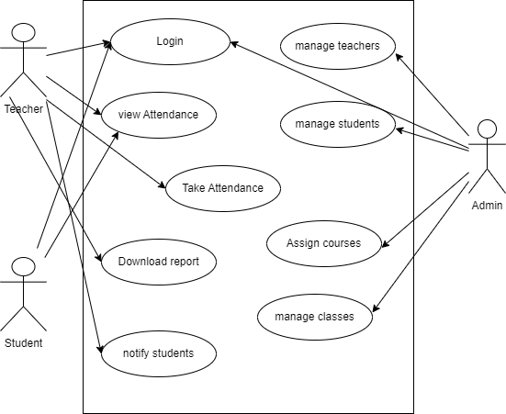

Fig: Use Case Diagram

5.4. Database Design
5.4.1. Database Table for Attendance

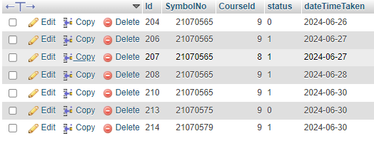
Table1:Database Table for Attendance

5.4.2. Database Table for class

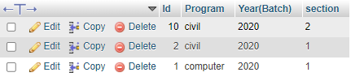
Table 2: Database Table for class

5.4.3. Database Table for Course

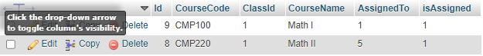
Table 3:Database Table for Course
5.4.4. Database Table for Teacher

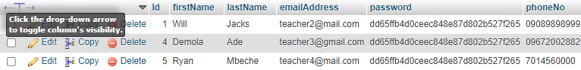
Table 4: Database Table for Teacher

5.4.5. Database Table for Student

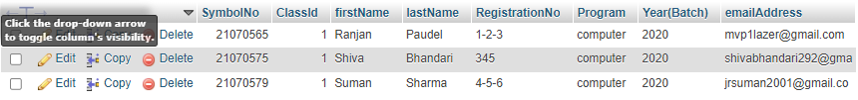
Table 5: Database Table for Students

CHAPTER 6: TESTING

6.1. Test Cases and Result

S.N. | Testing Cases | Results
1. | To Verify the successful login for user | Passed
2. | To verify the attendance for the different students from different faculty | Passed
3. | To verify real-time update of attendance status | Passed
4. | To verify alerts for absent students and send e-mail notification | Passed
5. | To verify generation of attendance reports for a specific period | Passed
6. | To verify different access levels for students, teachers, and administrators | Passed
Table 3: Testing activities and testing result

CHAPTER 7: CONCLUSION

7.1. Conclusion
• The online attendance system addresses inefficiencies and inaccuracies in manual methods.
• Agile methodology ensures flexibility and continuous improvement.
• Automating attendance tracking reduces time and administrative effort.
• Real-time data access and enhanced communication improve monitoring and transparency.
• Despite limitations like internet dependency and initial costs, the system's benefits make it a valuable tool for educational institutions.

CHAPTER 8: REFERENCE

- Welling, L., & Thomson, L. (2009). PHP and MySQL Web Development (4th ed.). Addison-Wesley Professional.
- PHP: Hypertext Preprocessor. (n.d.). PHP Manual. Retrieved from https://www.php.net/manual/en/
- Bootstrap Documentation. (n.d.). Retrieved from https://getbootstrap.com/docs/
- jQuery Documentation. (n.d.). Retrieved from https://api.jquery.com/
- StackOverflow, At https://stackoverflow.com/

APPENDIX
- Screenshot of login page
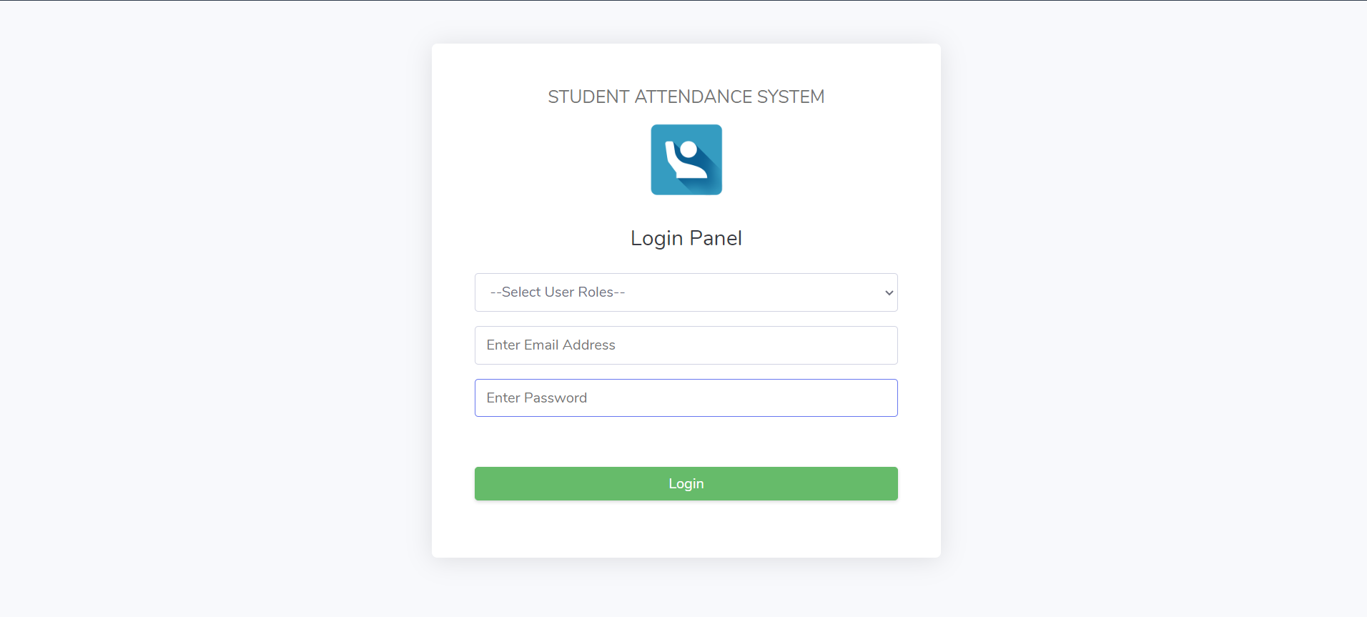
Fig: Screenshot of login page

- Screenshot of Student login page
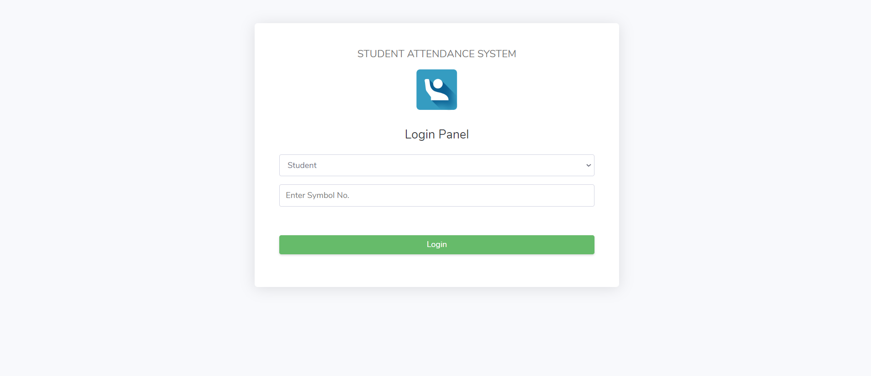 Fig: Screenshot of Student login page
- Screenshot of Take Attendance

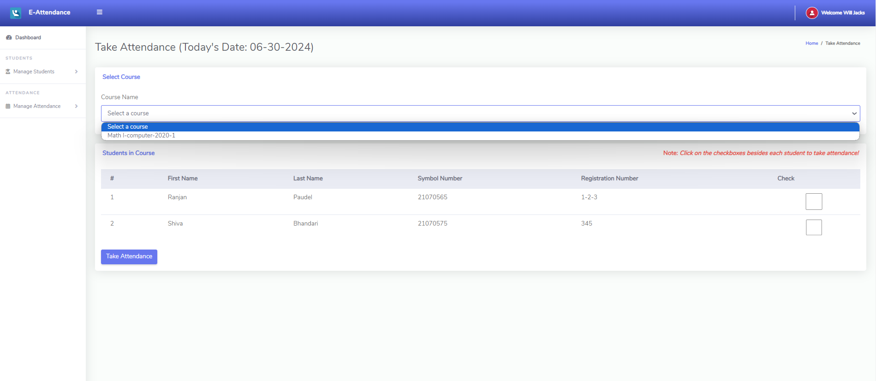
Fig: Screenshot of Take Attendance

- Screenshot of Admin Dashboard
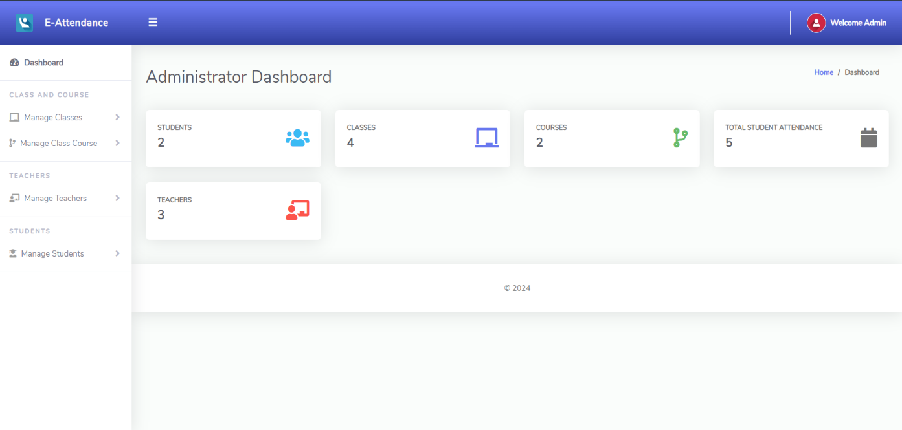Fig: Screenshot of Admin Dashboard
- Screenshot of Student Dashboard

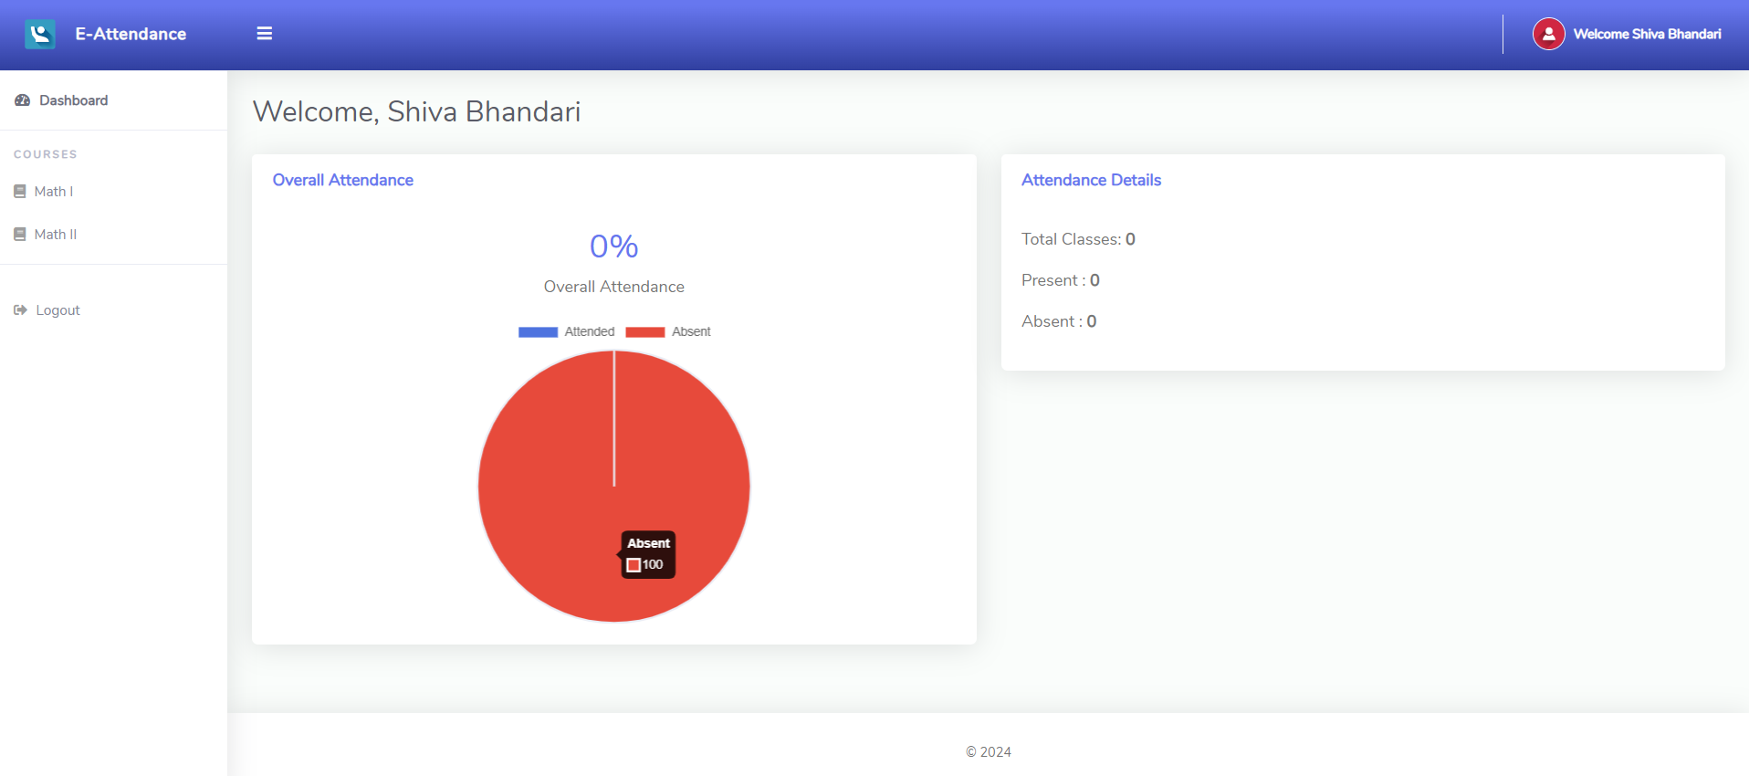
Fig: Screenshot of Student Dashboard

